**Stage Two: Human Computer Interaction I**

Students: Elliot Evans, Favian Silva, Neera Patadia, Rumika Mascarenhas, Panagiota Fytopoulou

**Link to Portfolio:** [**https://vezwork.github.io/CPSC-481-Portfolio/**](https://vezwork.github.io/CPSC-481-Portfolio/)

**Link to Repository:** [**https://github.com/FavSil/481HCI**](https://github.com/FavSil/481HCI)

**Project: UnRestrictedTM**

**Project Description**

Unrestricted is **the** food app for people with dietary restrictions. The target audience is ideally those individuals who need to or would like to ensure that a certain food is excluded from their dish, but it is open to everyone who would like to use it regardless! The way the app would be used is when deciding on where to eat out. The task of determining which restaurants are friendly to certain dietary restrictions can be daunting, and this app should ease the pain. Users can log in to the app and have options of restaurants or dishes to try. Users will be able to see other users’ reviews of restaurants or dishes, and what the reviewer’s restrictions are so that they feel more confident. For example, user A with celiacs disease might see a different user B’s review and decide on a restaurant based on the fact that user B is also celiac and did not have a negative experience at that particular restaurant.The user will be able to see the restaurant’s website as well as location in relation to their own coordinates.

**Stakeholders:**

* ***Users***: They use the app to find restaurants that cater to their dietary restrictions.
* ***Restaurants***: They are affected by the reviews users leave and it affects their reputation and income because if they receive bad reviews -- they might be less frequented.
* ***Servers***: They are indirectly involved in that they have less explaining to do if the app is successful in explaining their substitutions and restricted diet dishes. This also means that the servers would have more time for customer service.
* ***Development Team***: The team has a stake in the app in that they want it to succeed to be able to put it on their portfolios.
* ***Investors***: We do not have any investors, but if we did, they would have a stake as well.
* ***Professor/TA***: Those who are grading this project have a stake as well as they need to assess its value and usability.

**Users:**

* Users are individuals who use the app, the targeted audience is people with dietary restrictions, but all individuals are welcome.
* Users will most likely be individuals with access to a phone and internet connection as well as the ability to maneuver the device, this means that their knowledge and background in devices is basic.
* Users who are aware of dietary restriction limitations, what foods and ingredients they are unable to consume -- this requires dietary/nutritional knowledge on the user.

User **Research** Methods:

1. Survey

**Surveys** are used because we wanted to keep responses anonymous. The aspect of anonymity is important as it is easier for someone to answer these questions without judgement. This also gives us the ability to automatically extract statistical data from the survey as we are implementing it on Google Forms.

We conducted this method first and this guided us when coming up with server interview questions.

1. Server Interviews

The **Server Interviews** serve to give an insight into the actions of individuals within a restaurant environment. This will “fill in the blanks” of the missing information of the **Survey** done as first research method.

1. Empathy Tools

This is easier to implement than other methods for example Shadowing, or Fly on the Wall, as the latter two would take a considerable amount of time to execute. This method involves the development team dining out and experiencing dietary restrictions themselves.

1. Secondary Research

This research method will help us learn about the broader context and examine apps that already exist. This will help us understand what worked for users with food restrictions and what aspects of existing apps can be improved on.

Survey Questions

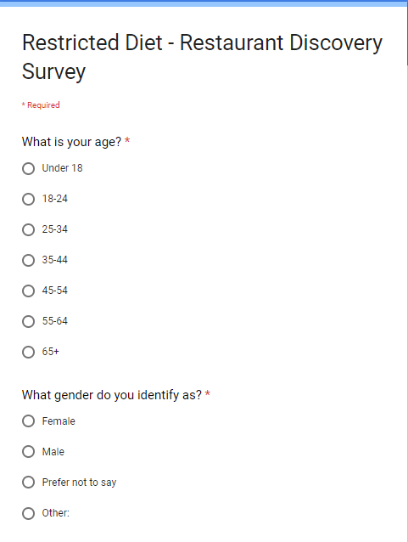

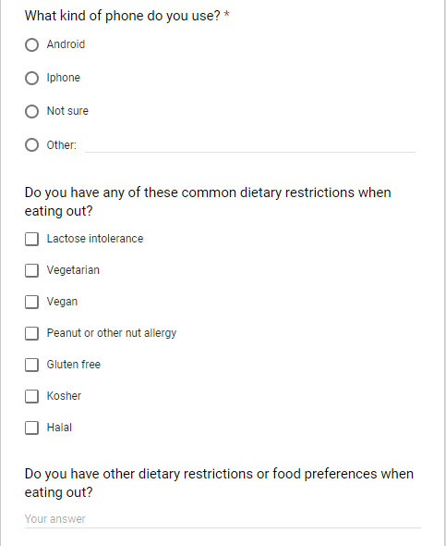

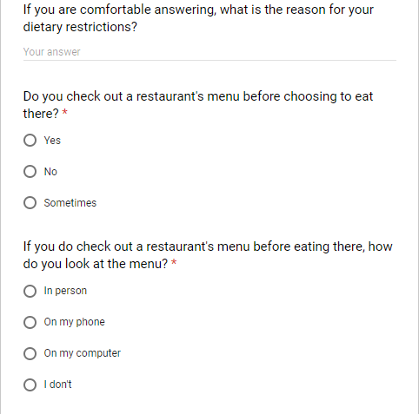

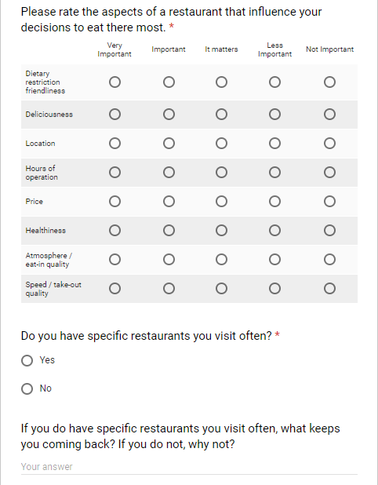

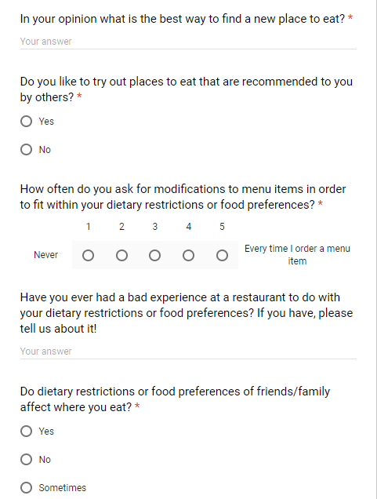

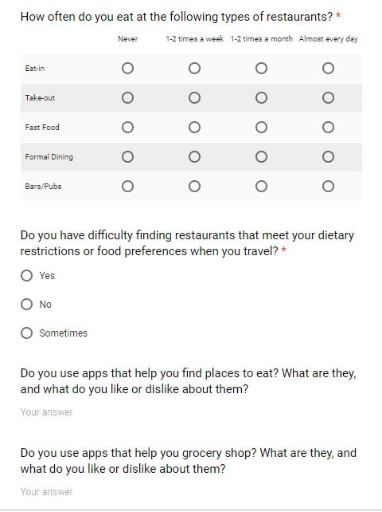

**Server Interview Questions**

1. How often do you work per week?
2. How busy is it usually?
3. Does the restaurant you work for have restriction friendly foods?
   1. What restrictions does your restaurant’s menu cover?
4. Does your restaurant allow for food substitutions per dishes?
   1. Do the substitutions cost more?
5. When helping customers with food orders, how many customers request food changes based on allergies per shift?
   1. 10 %, 20% etc
6. When customers ask for substitutions how easy is it to implement this at your restaurant?
7. How much time does it take to explain the menu and restrictions/substitutions?
8. Would you find it helpful if the customers knew of substitutions before hand.
9. How confident would you feel of knowing food allergies on items on the menu.

**Summary of Findings from Research Methods**

1. **Survey:**

**Representation of participants with food restrictions**

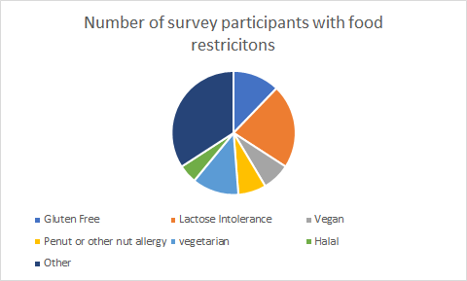

Fig 1: Food restrictions represented through the survey

There were a total of 49 responses from the survey and 71% of the individuals surveyed had some kind of food restriction or food allergy. The “Others” restrictions covered restrictions and allergies that were not presented as an option in the survey. This indicates how complex dietary restrictions can be. From this we decided to provide additional restriction settings when users set up their portfolio

**Important aspects of Restaurants**

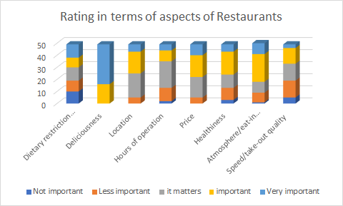

Fig 2: We can take away from this graph that “Deliciousness” is the most important aspect, followed by “atmosphere” and “price” when looking at data from all survey participants

Similar to existing food review apps, UnRestricted will integrate “Deliciousness” by allowing users to write reviews on the food items.

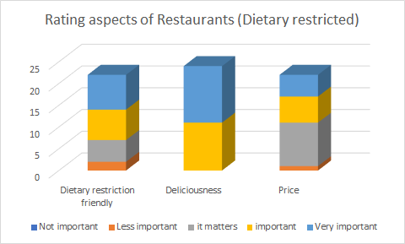

Fig 3: When focusing on responses with dietary restrictions only, the “Dietary restriction friendly” aspect is rated as important more often.

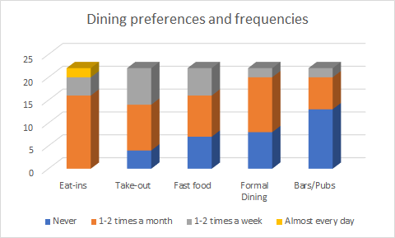

Fig 4: Our results indicated that the majority of surveyed individuals with dietary restrictions prefer Eat-in restaurants. When generating our underlying dataset for the app, we will include more Eat-ins, as they appear to be the most popular our target demographic.

**Best way to find new places to eat**

Most people relied on reviews from friends and the internet (Mainly Google reviews, reddit). In terms of Food review apps Yelp was the most used. One participant with Celiac disease said they relied on Celiac forums. Participants with Gluten Free restriction mentioned using “Find me GF” app. However, for their response they said that the option to leave/read a review was locked behind a paywall.

**Bad Experiences**

“Had a server get annoyed with me when I asked if there were any gluten free options other than salad, even when I specified that my gluten intolerance is medical and not a personal choice; there were no options other than side salads and french fries”

“Yeah the one time they gave my boyfriend fried parmesan chips when he's lactose intolerant.”

“Sometimes, I’ll come across a place that has limited options (as per my restrictions), poor taste in food and food that makes me feel sick.”

1. Empathy Tools

Favian:  
I went to Bridget Bar and ordered an appetizer that had cheese on it. I asked if the cheese could be removed from the dish, as I am lactose intolerant. When my dish came out, the main meal had the cheese removed, but came with cheese on the side. I told him that I wasn’t notified the meal came with cheese. He ended up taking care of the item however I was put off by his mistake and promptly ended the night.

Elliot:

I went to Craft Beer Market to grab a gluten-free pizza after work. I ordered the pizza and was assured that no gluten would be near the pizza making.The pizza took way longer to prepare because of my choice. When it finally came out the dough was extremely tough and chewy. I was disappointed with the whole experience wishing there was a way to find reviews of the gluten free option before, as most of the reviews I read were commenting on the regular version.

Rumika:

I went to the Garden of Italy, to get vegan meal. The restaurant had limited vegan options for pasta. I clearly indicated to the waiter that I was vegan. However, when I ordered one of the vegan options it came out with cheese on top. I feel like it would have been helpful to look at reviews indicating people’s experiences with dietary restrictions and have access to the menu.

Neera:

I went to Chanti’s to order a vegetarian meal. I notified the waiter that I was vegetarian, and she directed me to appropriate choices. I asked the waiter if I could substitute the meat in a dish. The waiter had to go to the kitchen to check if the substitution could be done. Ordering would have been easier if I knew beforehand what vegetarian options were and whether I could make substitutions.

Panagiota:

I prefer to not have eggs in my meals. I went to a ramen restaurant ordered their signature soup, and indicated I did not want the egg that came with the soup. I usually pretend I’m allergic to eggs to ensure that they omit the egg. However, the server seemed to understand my taste, so I said it was a preference. The soup came out and I tasted eggs. I asked the server what had happened, and they said that the kitchen had a misunderstanding when the server indicated that it wasn’t an allergy. They provided a new soup but everyone else had finished eating and I had to hurry because they were waiting for me.

Summary of Empathy Tools:

A common issue that we noticed when ordering with dietary restrictions was that servers can misinterpret the meaning of certain restrictions, and relay incorrect information back to the kitchen. Our experiences aligned with those stated in the Bad experience section. Also, restaurants with positive reviews may not have relevant dietary restriction reviews. All team members feel like it would have been useful to know how restartrants manage dietary restrictions by looking at relevant reviews and menu choices beforehand.

1. Server Interviews

The server is responsible to convey substitutions to management and kitchen staff. Gaining a perspective on this process was key to understand what the customer should know when going into a restaurant. From the interviews it was described that restaurants have menu items that cater to food restrictions. However the amount of items provided could be slim or the coverage of variation would be narrow. Modifications were often needed to cater more than one restriction.

Servers communicate with the kitchen for substitutions which satisfy the customers needs. This was time consuming as the server has to understand the restriction, the severity and make appropriate changes to the order, often re-confirming them with the customer. Take out restaurants (pizza places) have a refined menu with one or two specialty items. Substitution and dealing with allergies were more streamlined in restaurants like this. Most servers interviewed indicated that up charges are common for gluten-free substitutions.

Servers interviewed had very little knowledge of the ingredients on the menu(~50%), relying on kitchen communication to fill the gap. The large amount of communication between the server, kitchen and customer to ensure that their food comes out safe seems to be a concern for both the server and customer. Increased communication points can lead to increased breakdowns or misunderstandings. All servers suggested that having customers with knowledge on how their food restriction relates to the menu items would be much more efficient.

1. Secondary Research

Yelp

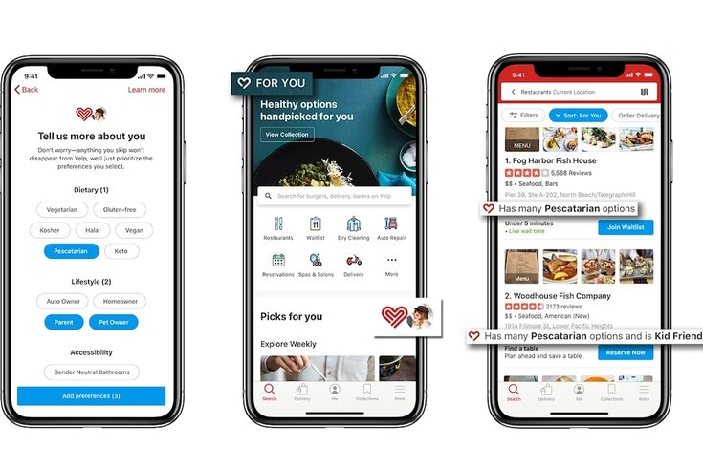

Yelp’s new feature allows the user to add dietary preferences into their profile. The app then shows the user if restaurants have food that accommodate their dietary preferences. However, when the results of a profile with and without any dietary restriction was chosen from the same location, the first recommendation for both was the same restaurant(1). This indicates that the app does not prioritize restaurants based on the specified food restriction.

Some restaurants have good food and service but are not good at accommodating dietary preferences. In such cases, Yelp generalizes reviews and they are not focused to dietary restrictions specified, which prevents users from making informed decisions. As indicated by our survey results, customers with dietary restriction consider “Dietary restriction friendly” as an important aspect. UnRestricted would be solely for users with dietary restriction, recommending restaurant with focused reviews on “Deliciousness” and “Dietary restriction friendliness”.

**Reflection on Research methods:**

The survey conducted provided a great source of information to give us an idea on how potential users manage their dietary restrictions when dining out. The questions on how frequently people eat out could have been improved by using less specific descriptors (ie. instead of asking if someone eats out 1-2 times per week, we could ask if the eat out a few times within the week, or most of the time during the week). Empathy tools allowed our team members to get an understanding of what individuals with dietary restrictions normally have to deal with when they dine out. The server interviews allowed us to understand how the restaurants themselves have to deal with individuals who have dietary restrictions. When conducting the interviews, we found that we needed to expand on the questions to get more information from the individuals we were interviewing. In addition, we feel like the interview questions could include additional information to gauge the experience of the servers we were interviewing, as more experienced servers would have a better understanding of the menu and how the kitchen for their restaurant works. A question like “How busy is it usually” doesn’t convey the sentiment that was expected. A question like “Does the busyness of a restaurant affect how you handle allergies” would better convey the need for a different system for handling allergies. The secondary research conducted, gave us the opportunity to evaluate the functionality of similar applications to those that we are proposing for this project.

**6-8 task descriptions:**

1. Setting up user profile for application
   1. The first task that the user can perform on the application will be to set up a user profile, indicating their dietary restrictions, location preferences and dining preferences (ie. do they prefer sitdown restaurants, fast food places, etc...)
2. Search for local restaurants that meet their dietary restrictions
   1. Using location information, users would be able to see restaurants that cater to their dietary restrictions in their local area.
3. Search for specific food options
   1. Users will be able to search for restaurants that offer the particular food option that they are craving.
4. View menus of restaurants
   1. Users will be able to see the menus of a restaurant that they are interested in.
5. Viewing reviews
   1. Users will be able to see the reviews of a particular restaurant to determine if it will meet their dietary needs.
6. Posting reviews
   1. Users will be able to post reviews and rating of a restaurant to share their experiences with other users of the application.

**References**

1. <https://www.wired.com/story/yelp-app-personalization/>